**Modify the Binary Search Tree as follows**

1. Start with BST.java and BST_Tester.java files that accompany this assignment.
2. Create a method called **toStringKeysByLevel()** that returns a string representation of the keys in the tree showing the hierarchical structure level by level.   Here is an example binary search tree shown in this way.

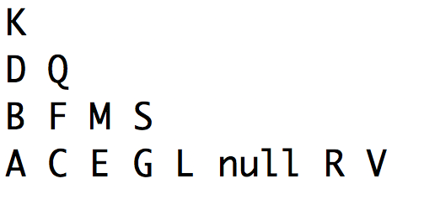

1. Create a new method called **deleteAlt(Key key)** that deletes a node by replacing the deleted node with a node from the left side of the tree instead of the right side of the tree.
2. Use the tester that I have written for you to execute “5. Test Me” and submit the output of this test with your java code. All of the code that you write in the BST.java file should be at the bottom of the file.
3. Upload the java code and the output and no other files. Please upload the files separately instead of putting them in a zip or compressed folder.